New York Midnight Diner

Finding the Best Location

Alaa TAAN

April 2019

# Introduction

Midnight Diner (深夜食堂, Shinya shokudō) is a Japanese anthology TV series based on the manga of the same name by Yarō Abe. The show focuses on a midnight diner, the chef, known only as "The Master", and his involvement with his customers.

The setting of Midnight Diner is a small 12 seat Izakaya called "Meshiya" in Shinjuku, Tokyo. Despite the restaurant's strange opening hours, 12 am to 7 am, it is popular with the busy nightlife of Shinjuku. The Shinjuku setting, and the hours of operation, means that much of the Midnight Diner story takes place at night.

The show was well received when it started streaming on Netflix. It has an IMDB rating of 8.4.

The popularity of the show inspired one businessman to open a midnight diner in Manhattan, New York. This report aims to find the best location for such a diner. The selected location must be in a neighborhood with active night life scene, and maybe with some Asian culture influences.

# Data

New York has a total of 5 boroughs and 306 neighborhoods. For NY geolocation data, I will use the same dataset used in the labs; available at <https://geo.nyu.edu/catalog/nyu_2451_34572> or <https://ibm.box.com/shared/static/fbpwbovar7lf8p5sgddm06cgipa2rxpe.json>

I will also use Foursquare API to get information about night life venues in New York. Like the lab, the explore end point will be used but now the category will be specific to night life.

# Methodology

In a nutshell this report is based on two data sources; New York geospatial data and Foursquare location dataset. So, the analysis is done in three steps.

The first step is to fetch and prepare New York geospatial data. The result of this is a list of Manhattan’s Neighborhoods along with the corresponding longitudes and latitudes.

The second step gets the needed location information for the above-found coordinates. I am going to use Foursquare API to get the number of nightlife spots and the number of Asian restaurants in each neighborhood.

The third step will be clustering Manhattan neighborhoods based on the information I got using K-means clustering algorithm.

## Step-1 Getting Manhattan’s Neighborhoods Coordinates

The search for the perfect midnight diner location starts by getting New York geospatial data from the above-mentioned repository. Now that I got the information in JSON format, I need to process it and load it into a pandas dataframe.

The dataframe shall have four columns – Borough, Neighborhood, Longitude, and Latitude. Furthermore, since we are only interested in Manhattan, we can filter out the neighborhoods which belong to Manhattan neighborhood.

There are 40 neighborhoods in Manhattan as you can see below.

Figure 1 Manhattan Neighborhoods Map

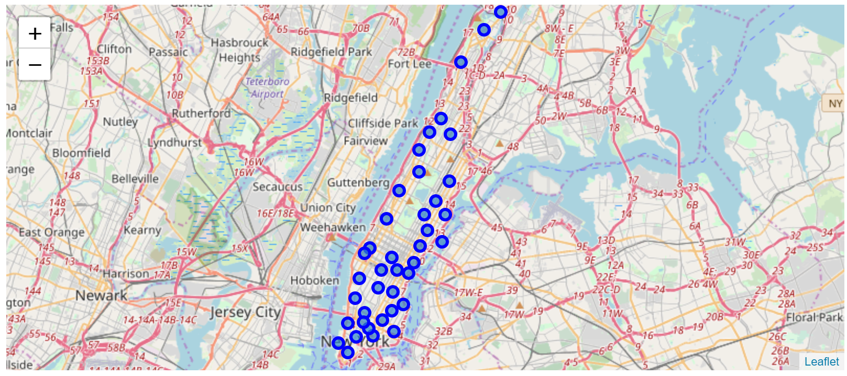

Figure 2 Manhattan Neighborhoods List

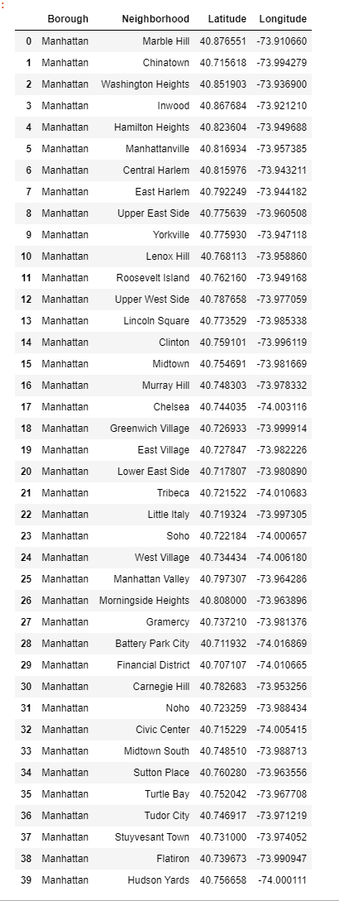

## Step-2 Getting Manhattan’s Venues Data

I am using Foursquare regular API endpoint ‘explore’. The parameter CategoryId is used to get recommendations for nighlife spots as well as Asian restaurants. Nightlife spot category ID: 4d4b7105d754a06376d81259. Asian Resturants category ID: 4bf58dd8d48988d142941735

Figure 3 Manhattan's Top Neighborhoods based on Nightlife Spots Count

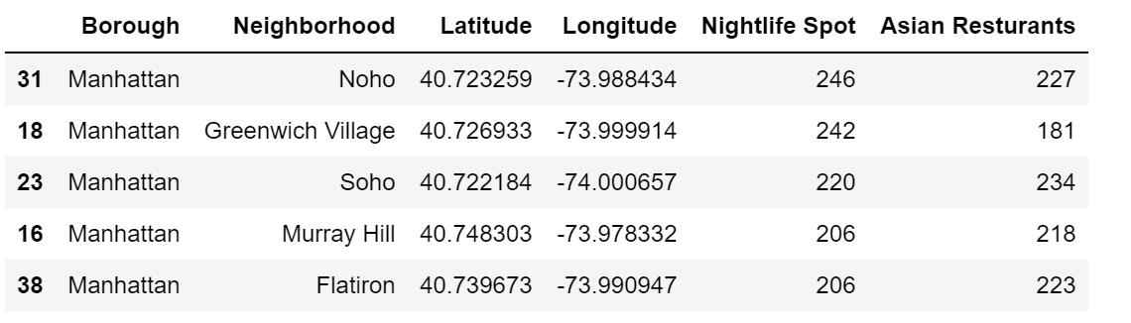

Figure 4 Manhattan's Nightlife Spots Per Neighborhood

Figure 5 Manhattan's Top Neighborhoods based on Asian Restaurants Count

# 

Figure 6 Manhattan's Asian Restaurants Count per Neighborhood

## 

## Step-3 Clustering the Neighborhoods

A quick look at the features selected for clustering shows that they are in the same range, so we may be able to proceed without scaling. See the boxplot below.

Figure 7 Count of Venues Boxplot

# 

However, and for the sake of good practice, I used MinMaxScaler to prepare the data.

Figure 8 Relative Count of Venues Boxplot

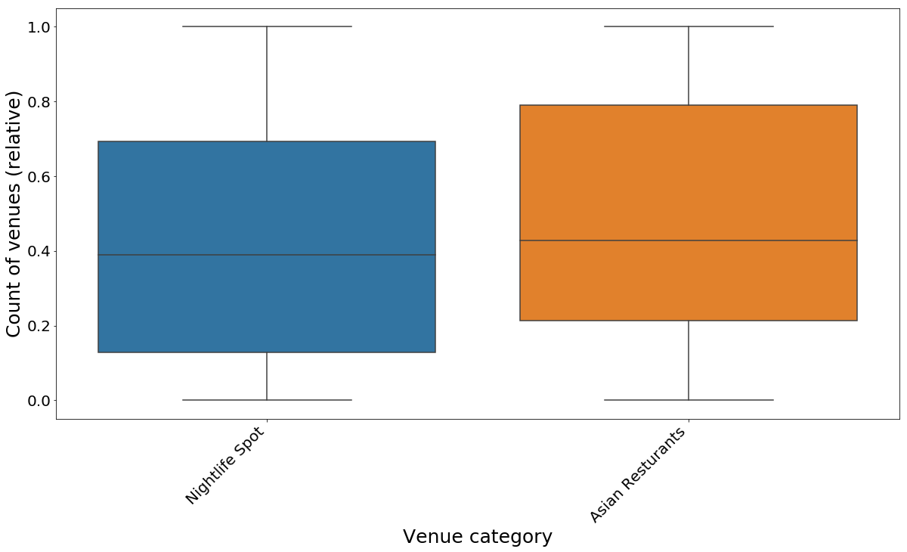

The result of running k-means is shown below. It is clear that Cluster 0 is the best neighborhood for our endeavor. It has the highest concentration of nightlife spots and Asian restaurants.

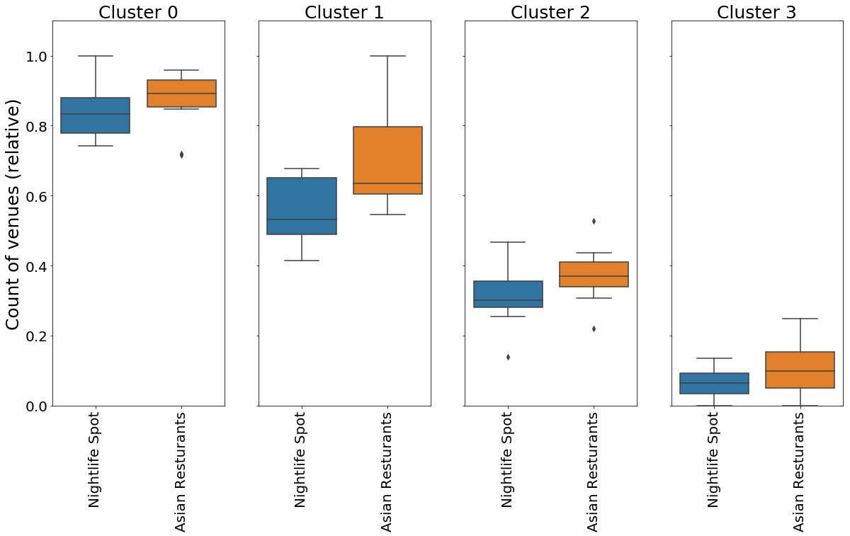

# Results

A Manhattan neighborhood typically has 50-170 night spots and 60 to 200 Asian restaurants, Cluster 0 has the highest numbers of all others. Here’s a list of the suitable neighborhoods for opening a midnight diner.

Figure 9 Neighborhoods for Midnight Diner

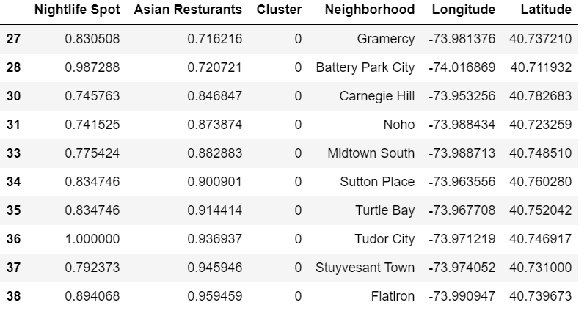

# Discussion

Based on the count of the two selected venue categories, 4 clusters of neighborhoods were identified – shown below.

The red cluster is the best cluster to open a midnight diner (cluster 0). Neighborhoods in the same cluster were found to be geographically close to each other (in general).

Figure 10 The Four Clusters (red=0, green=1, blue=2, yellow=3)

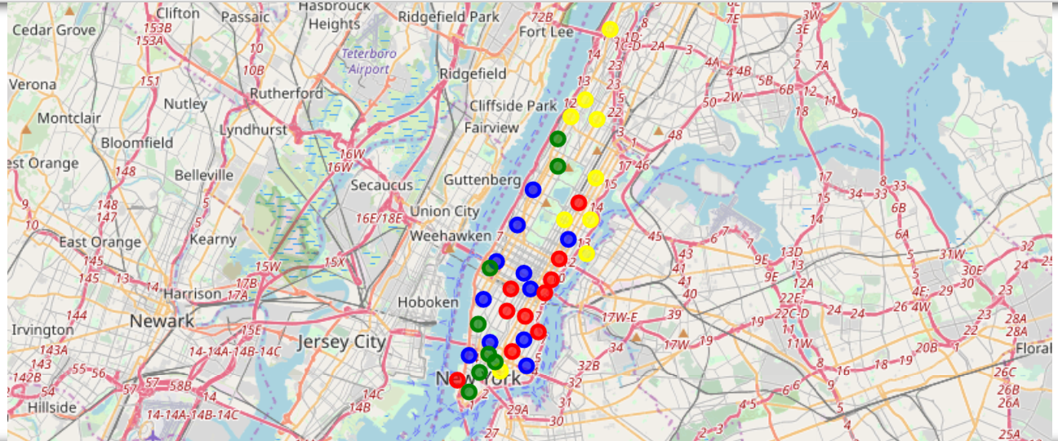

# Conclusion

A midnight diner in Manhattan can be a good idea. Manhattan is the most densely populated area in New York. It has a variety of nightlife spots and a lot of Asian pubs and restaurants.